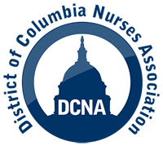
DCNA INFORMATIONAL PICKET ON STAFFING
DATE: January 13, 2022 (Thursday)
TIME: 8:30 – 10:30 am
LOCATION: HUH, 2041 Georgia Avenue, NW

- This is an informational picket; it is not a strike
An informational picket is designed to highlight issues that affect our members. In this case, it is to address the staffing crisis and to let the public know our concerns.
A strike involves workers refusing to go to work and is the ultimate job action. When a union strikes, workers refuse to go to work (and, as a result, do not get paid) until a contract agreement is reached.
- DCNA will not address specific contract proposals in this informational picket. We will, instead, focus on addressing the staffing crisis, as part of a nation-wide day of action. Nurses from all across the US are planning events in 100 facilities.

- You can participate in the picket if you are on scheduled annual leave, on your regular day off, or on an authorized break from work.

- Do not participate in the picket if you are on scheduled or unscheduled sick leave or on FMLA.

- This picket will conform to social distancing protocols; accordingly, DCNA will limit the amount of participants at one time during the picket. Please contact a representative or email to esmith@dcna.org to notify DCNA of your intention to participate and what time you plan to attend.

