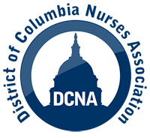

DC NURSES ASSOCIATION - SURVEY ON NURSE STAFFING
For years, the D.C. Nurses Association has fought for safe and appropriate staffing levels for registered nurses and other health care professionals. When the COVID-19 pandemic hit, the public became more aware of the serious crisis in staffing and the consequences of not having enough nurses to care for patients.

Please take a few minutes today to go to: https://docs.google.com/forms/u/0/d/e/1FAIpQLSd71JbbwXpnROczCYZRdsFlFqJNICzVsq1EL0U1oEyzHCeDow/formResponse
and respond to this survey on the current state of nurse staffing in the DMV. DCNA will hold your answers and information in confidence and will not distribute such information to any entity.

It is DCNA’s belief that the time is NOW to address the staffing crisis in the DMV and the United States. We hope to use the results from this survey to educate the public and create an opportunity to discuss solutions to the nurse staffing crisis.

