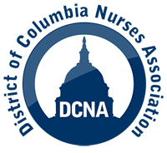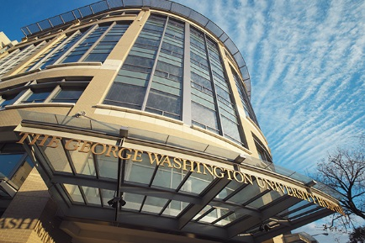

GW Nurses Look to Organize a Union for a
Collective Voice Advocating for Patient Care & Working Conditions

Today, we, the registered nurses of The George Washington University Hospital (a subsidiary of UHS) announce our intent to form a union represented by the District of Columbia Nurses Association (DCNA). Quality patient care and nurse retention are at the forefront of this decision.

We are driven by a desire to provide the safest, most compassionate and most patient-centered care possible. Unfortunately, repeated attempts to work personally and directly with hospital leadership have failed to yield lasting systemic improvements. The George Washington University Hospital is one of the prominent hospitals serving the DC community. We want to ensure that the hospital is a proper steward of the trust placed in them by the community, and treats patients with the dignity they deserve and staff with the respect we have earned.

Organizing with DCNA is the best way to achieve these goals, and we hope hospital administration will welcome this union as an opportunity to form a more constructive partnership with staff. This collaboration will lead to safer patient care by ensuring adequate staffing, improving training programs, developing consistent policies, and increasing nurse retention.
We take our responsibility to our patients and their families seriously, and view unionizing as a community service that will better enable us to provide high-quality care to those we serve. We believe that great progress can be made by all of us working together as a team.

February 10, 2023

Contact: Edward J. Smith, Esq. esmith@dcna.org
(202) 425-8011

DCNA, 1220 12th Street, SE, Suite G10, Washington, DC 20003; www.dcna.org

###

