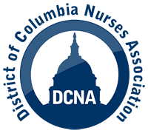
For Immediate Release
Contact: Edward J. Smith, esmith@dcna.org, (202) 425-8011
District of Columbia Nurses Association Endorses
Elissa Silverman for DC Council At-Large Member

Washington, D.C. September 12, 2022 - The District of Columbia Nurses Association (DCNA) announced today its endorsement of Elissa Silverman for the DC Council, At-Large member. Ms. Silverman has served on the DC Council since 2015.
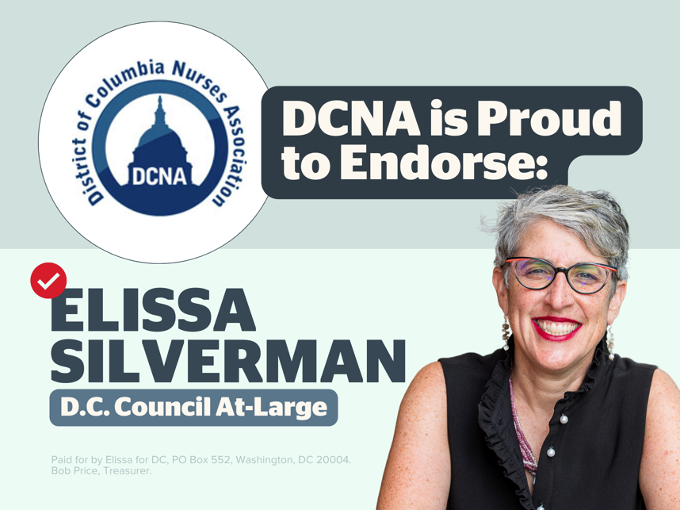
“Councilmember Silverman has been a tireless advocate for working people in the District of Columbia from Day One. She is a champion for nurses and other health care workers in our city and has consistently been available to discuss issues important to DCNA, including her fearless support of fair and equitable health services East of the River,” stated Edward Smith, Executive Director, DCNA. “She has worked hard to put education and training in place to create career opportunities in health care for District residents, which is an important way to close the health equity gap.”
Ms. Silverman also co-authored the District’s Paid Family Leave law, and as Chair of the Council’s Committee on Labor and Workforce Development, oversees its implementation. The program launched on-time and under budget in the midst of the pandemic.
DCNA, an affiliate of the National Nurses United, AFL-CIO, represents over 2,000 registered nurses in the District of Columbia.

