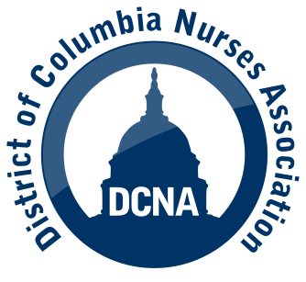

**DCNA & Howard University/Howard University Hospital**

**Contract Negotiations**

**Bargaining Bulletin # 2 – June 16, 2025**

* On June 4, 2025, DCNA and Howard University Hospital commenced bargaining over our successor collective bargaining agreement. The first session was an overview of each parties’ positions and no proposals were exchanged.
* On June 11th, DCNA presented HUH with our initial proposals, including compensation demands. We reached agreement with HUH to maintain the language on 15 articles in the collective bargaining agreement, including:
* grievance and arbitration rights and procedures
* recognition of the union as the representative of nurses, pharmacists, dietitians and social workers
* right to have union representatives meet with DCNA members in disciplinary meetings and in grievance investigations
* DCNA representation on numerous committees.
* We have also agreed to meet on June 24, 27 and 30.
* The contract expires on June 30, 2025. If DCNA believes progress towards an agreement is occurring at such time, we will seek to have an extension.

More information on back!



HUH discussed with the DCNA bargaining team two major issues which affect the operations of the hospital and the negotiations over a new contract.

1. Howard University recently announced that, effective February 2026, HU and Adventist Health Care will dissolve their partnership, in which AHC ran operations of the hospital. We were advised that this decision creates uncertainty and, as a result, may impact bargaining throughout the transition period.
2. We were also informed of a critical financial crisis at the hospital, with large deficits from Fiscal Year 2024 (July 1, 2023 – June 30, 2024) and projected for this Fiscal Year. We were advised that HUH is not prepared for at least a “few weeks” to bargain over compensation proposals.

Finally, regarding the building of a new hospital, we were advised that Howard University continues its plan; however, it has not finalized any construction agreement and could not state whether the building would be a new hospital or an extension of the current hospital.

HUH committed to keeping DCNA abreast of any and all new details on finances and the construction of a new hospital or extension.